Date: ___________
Practical No.04
Aim: Probability and Probability Distributions:
a. Simulate a probability experiment (e.g., rolling dice) using programming and calculate the probabilities of different outcomes.
b. Generate random numbers from various probability distributions (normal, uniform, exponential) and analyze their properties.
a) Simulate a probability experiment (e.g., rolling dice) using programming and calculate the probabilities of different outcomes.
Probability is the measure of how likely an event is to occur. When a fair die is rolled, each face (1 to 6) has an equal theoretical probability:
∙ Probability of each number = 1/6 ≈ 0.1667 (16.67%)
In a simulation, we roll the die many times using a computer. The experimental probability is calculated as:
Experimental Probability = (Number of times an outcome occurs) / (Total number of rolls)
INPUT:
import random
# Input: Number of times to roll the die
n = int(input("Enter the number of dice rolls: "))
# Dictionary to store frequency of each outcome
frequency = {1:0, 2:0, 3:0, 4:0, 5:0, 6:0}
# Simulate rolling the die
for i in range(n):
roll = random.randint(1, 6)
frequency[roll] += 1
# Display results
print("\nResults of Dice Rolling:")
print("----------------------------")
print("Face\tFrequency\tProbability")
for face in range(1, 7):
probability = frequency[face] / n
print(face, "\t", frequency[face], "\t\t", round(probability, 4))
OUTPUT:
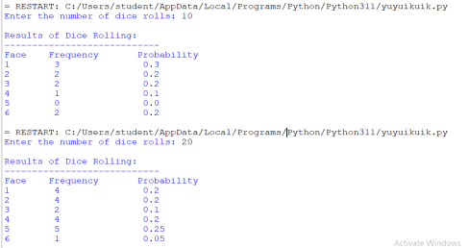Calculate Experimental Probability
1) probability = frequency[face] / n
For example:
If the die is rolled 20 times and Face 3 appears 5 times:
Probability = 5 / 20
= 0.25
2) Face: The number on the die.
Frequency: Number of times that face appeared.
Probability: Experimental probability (Frequency ÷ Total Rolls). 3) If you increase the number of rolls (e.g., 1000 or 10000), the
experimental probabilities will generally become closer to the theoretical probability due to the Law of Large Numbers.
b. Generate random numbers from various probability distributions (normal, uniform, exponential) and analyze their properties.
Theory
Probability distributions describe how values are distributed in a dataset.
1. Normal Distribution
o Bell-shaped and symmetric.
o Characterized by mean (μ) and standard deviation (σ). o Used in natural phenomena such as heights, weights, and exam scores.
2. Uniform Distribution
o Every value within a given range has an equal probability of occurring.
o Defined by lower and upper limits.
3. Exponential Distribution
o Models the time between independent random events.
o Commonly used in reliability analysis and waiting-time problems. INPUT:
import numpy as np
# Generate the same random numbers every time
np.random.seed(10)
# Input: Number of samples
n = int(input("Enter the number of samples: "))
# Generate random numbers
normal_data = np.random.normal(loc=50, scale=10, size=n) uniform_data = np.random.uniform(low=0, high=100, size=n) exponential_data = np.random.exponential(scale=5, size=n)
# Function to display statistical properties
def analyze(data, name):
print("\n" + "=" * 45)
print(name)
print("=" * 45)
print("Generated Values:")
print(np.round(data, 2))
print("Mean :", round(np.mean(data), 2))
print("Minimum Value :", round(np.min(data), 2))
print("Maximum Value :", round(np.max(data), 2))
print("Standard Deviation :", round(np.std(data), 2))
# Analyze all distributions
analyze(normal_data, "Normal Distribution")
analyze(uniform_data, "Uniform Distribution")
analyze(exponential_data, "Exponential Distribution")
OUTPUT:
